Maundy
Thursday

: Items Needed:

- Bible
- Large bowl with water
- Cup
- 2 Towels
- Chair for sitting
- At least 2 people

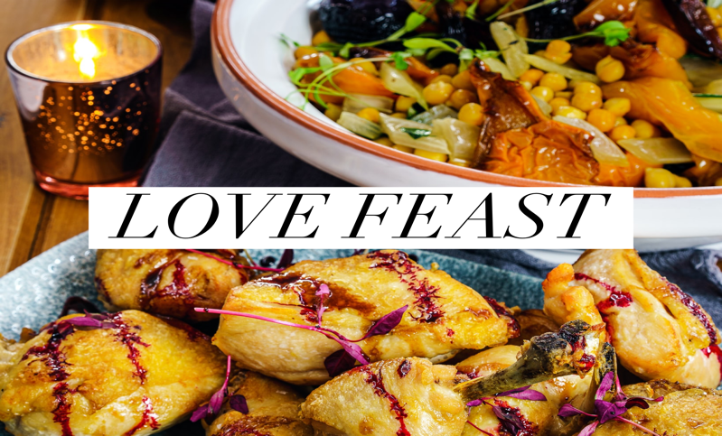
Read John 13. The lesson for this day is humility and servanthood. Jesus washed his disciples feet teaching them these lessons. I will encourage you to not worry about the look of your feet or whether or not you are using a proper bowl for this activity. The goal is to serve each other in humility. The Son of God washed feet, teaching us to do the same. Have one person sit in the chair (person 1). I would recommend putting a towel under the bowl of water. Then have person 1 put their feet either in the water or above it. Have the person washing feet (person 2) scoop water in the cup and pour the water over the feet. Then dry with a towel. Take turns throughout your family washing each other’s feet. It’s a truly humbling experience.

Typically on Maundy Thursday we would share in Holy Communion together, in the United Methodist Church we believe communion to be a means of grace received in community. Since we are socially distant this day we will not have communion, we are able to share in a Love Feast. This experience is meant to be done as part of a family meal. I invite you to make this dinner a family time. Turn off and put away all phones and other electronics. Light candles if you’d like. Dinner does not have to be anything fancy, the importance is being together as a family, praying together and reading scriptures together. Read Matthew 26: 17-30. Suggested Prayer: Father of earth and heaven, feed your hungry children, please give us your grace, speak into our spirits, you are the true bread of life, give to all of humanity your saving grace. Recite the Lord’s Prayer. Our Father, who art in heaven, hallowed be thy name, thy kingdom come, thy will be done on earth as it is in heaven, give us this day our daily bread and forgive us our trespasses as we forgive those who trespass against us. Lead us not into temptation but deliver us from evil, for thine is the kingdom and the power and the glory forever. Amen.
Read more about the tradition of the Love Feast at https://www.umcdiscipleship.org/resources/the-love-feast

